Victorian Government submission to the Royal Commission into Victoria’s Mental Health System

To receive this publication in an accessible format email Royal Commissions Engagement Branch <mhrc@dhhs.vic.gov.au>
Authorised and published by the Victorian Government, 1 Treasury Place, Melbourne.
© State of Victoria, Department of Health and Human Services July, 2019.
Where the term ‘Aboriginal’ is used it refers to both Aboriginal and Torres Strait Islander people. Indigenous is retained when it is part of the title of a report, program or quotation.
ISBN 978-1-925947-25-0 (pdf/online MS word)
Available at The Royal Commission into Victoria’s Mental Health System <https://www2.health.vic.gov.au/mental-health/priorities-and-transformation/royal-commission>

Contents
Foreword 1
Executive summary 2
1 The current mental health system in Victoria 5
1.1 Mental health service delivery 5
1.2 Mental health system policy and planning 10
1.3 Current initiatives to improve the mental health system 10
2 A model for the future mental health system 14
3 Challenges facing Victoria’s mental health system 20
3.1 Early engagement gap 22
3.2 Treatment gaps for people with moderate or enduring mental illness – the ‘missing middle’ 23
3.3 Treatment gaps for people with severe mental illness 24
3.4 Treatment gaps for children and young people 25
3.5 Gaps in the foundations of the system 26
4 Priority reform opportunities 30
4.1 Strengthening primary mental health care 30
4.2 Expanding community-based care 31
4.3 Contemporary models of care for people who are severely unwell 31
4.4 Better using other service systems to promote and support mental health 32
4.5 Enhancing child and youth mental health 33
4.6 Strengthening foundations of the system 33
Appendix 36
Description of figures 36

Foreword
The numbers are staggering.
In 2017, we lost more than 600 Victorians to suicide
Nearly half of all Victorians will experience a mental illness in their lifetime.
And around one in five Victorians will experience mental illness this year alone.
It’s impacting families and friends, colleagues and communities.
And the truth is, we don’t have the best mental health system we could – or should – have.
When there are Victorians still struggling, and families still suffering, we can do better.
We must do better.
It’s the reason we promised to establish our nation’s first Royal Commission into Mental Health.
And with it, a necessary acknowledgement:
When it comes to fixing the flaws in our mental health system, we don’t have all the answers.
It’s why, from prevention to intervention, quality to cost, the Commission’s is an open investigation with nothing off the table.
Importantly, this work is being led by the voices of Victorians, with submissions, round-tables, community meetings and open forums across our state.
Now with this initial submission – and as part of the next stage of consultation – we’re working on the fundamental reimagining and reforming our mental health system.
Working together, we’ll take action.
We’ll find answers.
And we’ll change and save lives.

The Hon. Daniel Andrews MP
Premier of Victoria

Martin Foley MP
Minister for Mental Health

Executive summary
This submission to the Royal Commission into Victoria’s Mental Health System (the Royal Commission) is made on behalf of the whole of the Victorian Government.
The pressures on our mental health system are well documented and are sadly too familiar to many Victorians. We know some people in our state are impacted by poor mental health more than others, including Aboriginal, LGBTIQ+, regional and rural, and culturally and linguistically diverse Victorians.
Most tragically, poor mental health can result in suicide. And for every suicide there are many more people – family, friends, carers, colleagues and communities – who are deeply affected.
Our obligation to those who have lost loved ones and to those dependent upon our system for care is not just to hear their stories, but to support the Royal Commission to understand how and where our system breaks down, so that we can build a better one.
In designing a future mental health system, it is critical that that we focus on the outcomes we want to achieve for people living with mental illness, their families and carers, and the community.
In the future, we want all Victorians to be healthy and well, irrespective of their background, circumstance or where they live. Our vision is for:
- Victorians to have good mental health and wellbeing
- Victorians to act to protect and promote health
- Victorians living with mental illness have fulfilling lives of their choosing, including opportunities to participate in the economy
- All services to be accessible, flexible and responsive to people living with mental illness, including their families and carers, and the workforce supported to deliver this.
For individuals, achieving these outcomes will reduce the impact of mental illness on their lives, the lives of their families and carers, as well as the broader community through increased social and economic participation.
In essence, we want to deliver person-centred mental health treatment and care, which targets the needs of the individual at any stage of illness, including before a person becomes unwell.
Collaborating with our service delivery partners and their dedicated workforce is crucial to deliver this vision.
It also represents an opportunity to redesign Victoria’s mental health system, based on a model of stepped care and reposition our state as a leader in mental health promotion and care.
The stepped care model is a nationally-agreed framework for reform, outlined in the Fifth National Mental Health and Suicide Plan. It is focused on building connections between the continuum of mental health services, from the least to the most intensive.
By implementing this model, we would seek to create a complete system of care that supports people to recover at any stage of illness. Adopting this model would involve:
- identifying different ‘needs groups’ within the population
- defining different interventions for each group, recognising that not all groups require a specialist mental health intervention
- developing a suite of evidence-informed services to respond to different needs across the spectrum of care
- matching services to each needs group
- designing effective pathways between services.
A critical aspect of such a model would be to ensure the system can flexibly respond and maintain continuity of care when a person experiences a major change in their circumstances.
This could include when they move in or out of services as their needs change. It could also include situations where a person experiences family violence or homelessness, enters into contact with the criminal justice system, or becomes a victim of crime.
Other health, social and justice service systems also have a critical role to play in promoting mental health, preventing mental health conditions and intervening early.
This includes addressing broader risk factors of poor mental health, such as social isolation and harmful AOD (alcohol and other drug) use. It also involves recognising that some people are more likely to experience mental illness due to their personal background or circumstances, and that some cohorts, such as women and Aboriginal Victorians, are overrepresented in mental health services.
When considering Victoria’s mental health system against the elements of a stepped care model, this submission identifies five key gaps in the system:
- an early engagement gap
- treatment gaps for people with moderate or enduring mental illness – the ‘missing middle’
- treatment gaps for people with severe mental illness
- treatment gaps for children and young people
- gaps in the foundations of the system (i.e. governance, funding mechanisms, data and information systems, workforce and infrastructure).
Six reform priorities are proposed to address these gaps and improve access to well-coordinated services of varying levels of intensity, delivered in a way that is appropriate to every individual’s personal circumstances. These reform priorities are:
  - strengthening primary mental health care
- expanding community-based care
- contemporary models of care for people who are severely unwell
- better use of other service systems to promote and support mental health
- enhancing child and youth mental health
- strengthening the foundations of the system (i.e. governance, data and information systems, workforce, infrastructure and research and innovation).
We recognise that advancing these priorities will require partnership across the health sector, including the specialist mental health sector, with broader community and social care services and across all levels of government.
It will also require changes in attitudes and behaviours to reduce stigmatisation and exclusion of people living with a mental illness and greater support for their families and carers.
The Royal Commission’s process will ensure all parts of our community, including people with a lived experience of mental illness, and all levels of government can contribute to a robust inquiry into the challenges faced by our mental health system.
A broad range of perspectives is needed to define an effective model focused on recovery, while also setting future reform directions.
Throughout this process, the Victorian Government will continue to work to improve support for Victorians with mental health issues by implementing existing initiatives and by addressing recommendations made by the Victorian Auditor-General’s Office in two recent reports on the specialist system.
We will also engage with related inquiries, including the Productivity Commission’s inquiry into mental health and the Royal Commission into Aged Care Quality and Safety.
We invite the Royal Commission to explore these reform priorities, alongside others contributed by the broader community, and provide advice on the practical sequencing of actions to improve Victoria’s mental health system.

The current mental health system in Victoria
Responsibility for the funding and delivery of mental health services in Victoria is shared between the Commonwealth and State Governments.
There are also numerous other partners and collaborators in the delivery of the mental health service system, including public health services, private mental health service providers and non-government mental health service providers.
The Commonwealth primarily supports people with less severe mental illness by funding mental health treatment in primary care, delivered by general practitioners (GPs) and other providers via the Medicare Benefits Schedule (MBS) and the Pharmaceutical Benefits Scheme (PBS).
The Victorian Government largely supports specialist clinical services, which treat approximately 72,000 people with severe mental illness each year. These services include inpatient units for people with acute mental illness and community-based services for people with enduring or longer-term needs.
A significant change is taking place because of the introduction of the National Disability Insurance Scheme (NDIS). Most of Victoria’s psychosocial support services are currently transitioning to the NDIS, which is jointly funded by the Commonwealth and the state.

Mental health service delivery
Nationally, over $9 billion is spent on mental health services each and every year. Of this, around 62 per cent is spent by state and territory governments, 32 per cent by the Commonwealth and 6 per cent by private health insurance funds.
In 2018-19, the Victorian Government allocated approximately $1.9 billion to mental health and alcohol and other drug (AOD) services. The total allocation grew to over $2 billion in 2019-20. While not quantified, the Victorian Government also funds an array of other health, education and justice services that contribute to mental health outcomes.
Figure 1: Expenditure on mental health services in Victoria
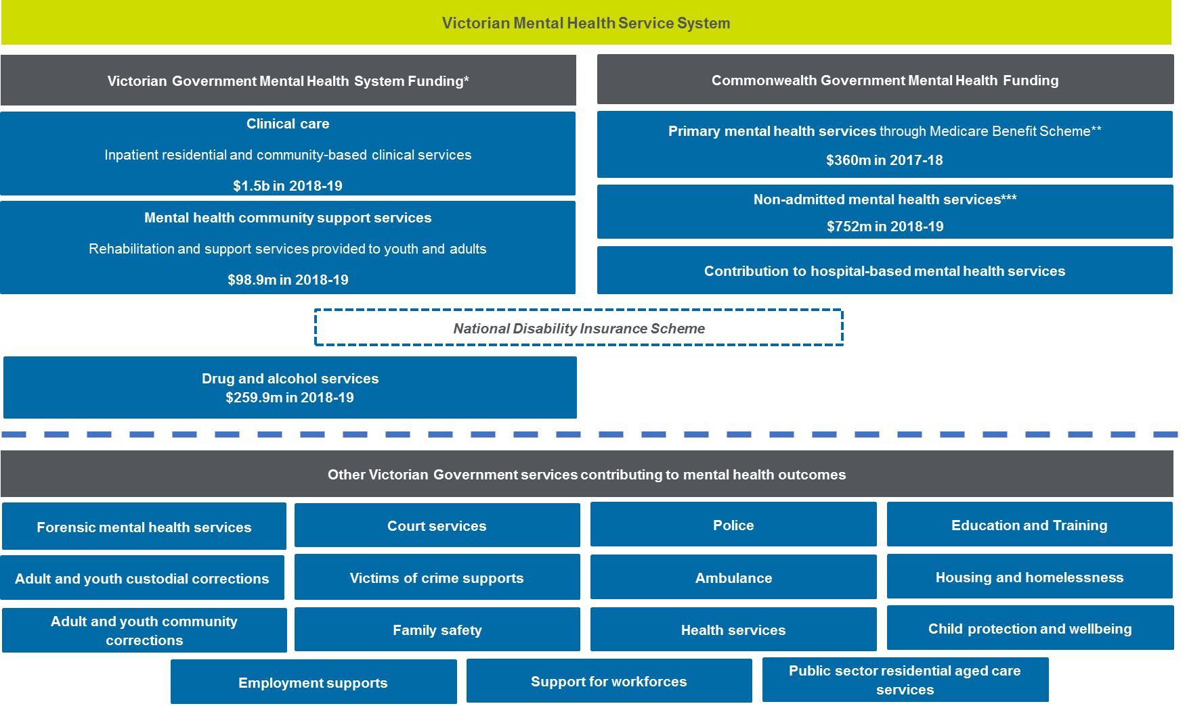

Commonwealth mental health services in Victoria
The Commonwealth supports the delivery of mental health services through the Medicare Benefits Schedule (MBS) Better Access Initiative and Pharmaceutical Benefits Scheme (PBS). These are provided by general practitioners (GPs), psychiatrists, psychologists and other allied health professionals.
Victorians access Medicare-subsidised mental health-related services at a higher rate than any other state or territory.
In 2017-18, approximately 11 per cent of Victorians received subsidised mental health-related services compared to a rate of 10.2 per cent for all Australians. The average benefit paid was $56 per person compared to a national average of $49 per person.
Most of these services are delivered in primary care settings by GPs, with 578,576 Victorians accessing mental health-related services through a GP in 2017-18. The number of people approaching GPs for mental health support has been increasing by around 8 per cent each year since 2013-14.
The Commonwealth has also influenced the way Victorians access primary mental health support through the establishment of Primary Health Networks (PHNs). These organisations present new opportunities to improve the integration of mental health services with primary health, AOD services and chronic disease programs.
PHNs also support delivery of mental health promotion, suicide prevention and early intervention services, including the national youth mental health platform, headspace. In suicide prevention, PHNs are collaborating with the Victorian Government to co-fund and implement 12 place-based suicide prevention trials.
As noted above, the transition to the National Disability Insurance Scheme is changing how non-clinical (or psychosocial support) services in the community – known as mental health community support services – are delivered. $80 million over four years was committed in the 2017-18 Federal Budget for the National Psychosocial Support (NPS) measure, alongside the Victorian Government’s co-contribution. The Commonwealth component of the NPS measure will be implemented through purpose-specific funding to PHNs to commission these new services.
At the same time, there are even more opportunities for further collaboration on suicide prevention between Victoria and the Commonwealth.
In addition to supporting people with less severe mental illness, the Commonwealth also supports the delivery of acute services in hospitals for people who are severely unwell, through the National Health Reform Agreement. Nationally, the Commonwealth also contributes funding to a range of 24-hour telephone-based counselling services and supports various workforce development initiatives.

Victorian Government mental health services
The Victorian Government supports the delivery of specialist clinical mental health services in our state’s hospitals and community settings, investing approximately $1.5 billion every year. This includes delivery of specialist services delivered by the Victorian Institute of Forensic Mental Health (known as Forensicare). It also includes support for residential services such as prevention and recovery care services in the community.
This funding supports approximately 72,000 consumers to access clinical services each year, around one third of whom are new, through the provision of more than 2,500 specialist mental health beds in a range of settings and around 1.3 million hours of community-based services.
The Victorian Government also provides approximately $99 million to support the delivery of non-clinical mental health community support services (MHCSS). Victoria’s contribution to the NDIS includes approximately $77 million of MHCSS funding each year. Extra interim funding was allocated in 2018-19 for new psychosocial support services for adult clients of clinical mental health services who are not eligible, or not currently receiving support, under the NDIS.
Victorian Government funding is also allocated to AOD services, approximately $273 million in 2019-20. Funded AOD programs include treatment – for example, counselling, residential and community-based rehabilitation services, and residential withdrawal services – delivered through community-based providers, along with prevention and harm reduction services, education initiatives to prevent and reduce AOD misuse and programs to support families.
There is a complex relationship between substance misuse and mental illness. The Diagnostic and Statistical Manual of Mental Disorders (DSM-5) includes Substance Use Disorder and Addictive Disorders. Studies suggest that around 50 per cent of people living with mental illness also have an addiction issue – a rate that is significantly higher than that of the general population.
It’s why it is critical that people get access to the treatment they need for their addiction issues, as well as their broader mental health needs.
It is also important that initiatives are appropriately targeted to prevent and reduce the harm associated with problematic substance use, and the accompanying mental health issues associated.
Figure 2 provides a breakdown of Victorian Government expenditure on mental health and AOD services.

Figure 2: Victorian Government’s mental health output cost, 2018-19
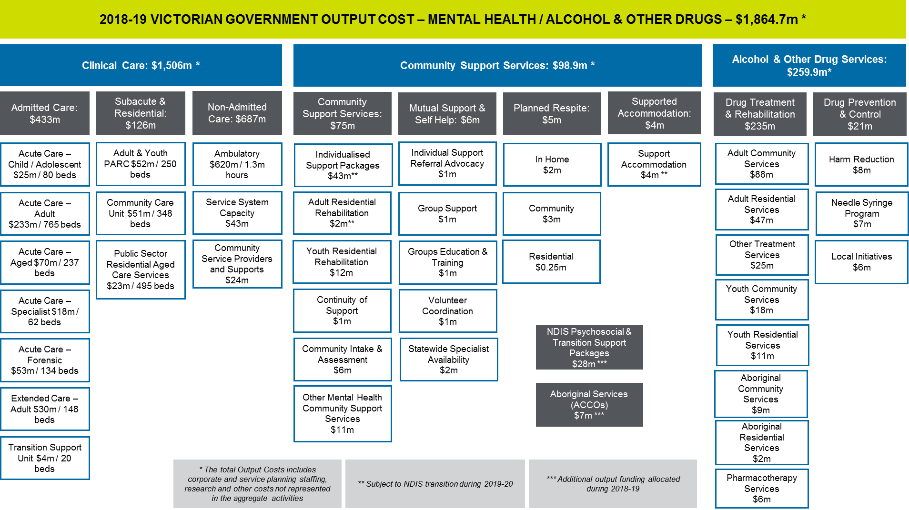

It is important to note that this overview reflects the Victorian Government’s expenditure on mental health and AOD services and does not necessarily fully reflect need for these services.
Demand for mental health services is often ‘unmet’ or ‘hidden’ due to the nature of mental illness, meaning that the most unwell may be less likely to seek out treatment.
This overview also does not cover wider Victorian Government services that contribute significantly to mental health outcomes for individuals, their families and the community. Examples include:
- mental health promotion, illness prevention and suicide prevention activities in the community and workplaces
- mental health support and treatment provided in conjunction with other physical health services
- mental health supports delivered through Victoria’s network of community health services
- student health and wellbeing supports in early learning, schools and tertiary education settings
- mental health treatment and support for people in contact with the criminal justice system, including police, courts, corrections and youth justice
- mental health support for people experiencing and escaping family violence
- mental health supports for people experiencing housing instability or homelessness.

Mental health system policy and planning
The Commonwealth facilitates our nation’s mental health planning process, which seeks to achieve integrated service planning and delivery across Commonwealth, state and territory governments.
This national planning process commenced in the early 1990s when mental illness was recognised as a national priority and the ‘deinstitutionalisation agenda’ was endorsed as part of the first National Mental Health Strategy.
The process of deinstitutionalisation involved replacing stand-alone psychiatric hospitals with inpatient mental health services co-located with general hospitals or aged care services, and community-based clinical and non-clinical mental health services. Victoria was a leader in this process.
Since this time, successive Victorian Governments have engaged with the national planning process and led state-level improvement agendas for our state’s mental health system, including Victoria’s 10 Year Mental Health Plan, which has guided system reform since its release in 2015.
The current iteration of this process is the Fifth National Mental Health and Suicide Prevention Plan. The plan was endorsed by the Council of Australian Governments Health Council on 4 August 2017.

Current initiatives to improve the mental health system
In recent years, guided largely by the 10 Year Mental Health Plan released in 2015, the Victorian Government has laid critical foundations to stabilise and strengthen Victoria’s mental health system. This work has been underpinned by the guiding principles in the Mental Health Act. Key actions and initiatives are summarised below.

The Mental Health Act 2014
Following broad-ranging consultations over a five-year period and driven by rights and recovery-oriented principles and international best practice, the Mental Health Act 2014 came into effect in July 2014, repealing the Mental Health Act 1986.
The Act introduced new principles to support people living with mental illness to make and participate in treatment decisions and to have their views and preferences considered and respected. It also promoted new ways of working, while strengthening quality and safety.
There are twelve principles in the Act that guide the provision of mental health services in Victoria. Providers must have regard to these principles when providing mental health services.
Mental Health Act 2014 – Guiding principles
  - Persons receiving mental health services should be provided assessment and treatment in the least restrictive way possible with voluntary assessment and treatment preferred
- Persons receiving mental health services should be provided those services with the aim of bringing about the best possible therapeutic outcomes and promoting recovery and full participation in community life
- Persons receiving mental health services should be involved in all decisions about their assessment, treatment and recovery and be supported to make, or participate in, those decisions, and their views and preferences should be respected
- Persons receiving mental health services should be allowed to make decisions about their assessment, treatment and recovery that involve a degree of risk
- Persons receiving mental health services should have their rights, dignity and autonomy respected and promoted
- Persons receiving mental health services should have their medical and other health needs, including any alcohol and other drug problems, recognised and responded to
- Persons receiving mental health services should have their individual needs (whether as to culture, language, communication, age, disability, religion, gender, sexuality or other matters) recognised and responded to
- Aboriginal persons receiving mental health services should have their distinct culture and identity recognised and responded to
- Children and young persons receiving mental health services should have their best interests recognised and promoted as a primary consideration, including receiving services separately from adults, whenever this is possible
- Children, young persons and other dependents of persons receiving mental health services should have their needs, wellbeing and safety recognised and protected
- Carers (including children) for persons receiving mental health services should be involved in decisions about assessment, treatment and recovery, whenever this is possible
- Carers (including children) for persons receiving mental health services should have their role recognised, respected and supported.

Guided by the Act, significant efforts have been made to embed the voices of people with lived experience in both the policy development process and in frontline service delivery. The Victorian Government has a strong record of partnering with consumer and carer organisations to guide consumer-focused policy development and oversee the quality and safety of mental health services.
The Victorian Government is committed to ensuring the Act continues to reflect contemporary human rights and practice standards. Future review will explore how the Act can be strengthened, drawing on innovations in mental health law in national and international jurisdictions, changes in the local legislative environment, and developments in clinical practice, quality and safety.

System improvement
Over the past five years, significant additional investment of approximately $1.9 billion has been allocated to the mental health system through State Budget. Much of this investment has been focused on supporting more Victorians to access services.
Recent initiatives have sought to improve the mental health system, including efforts to:
- Prevent suicide, chiefly through two programs implemented as part of the Victorian suicide prevention framework 2016–25, place-based suicide prevention initiatives in local communities (implemented in collaboration with PHNs) and the Hospital Outreach Post-suicidal Engagement (HOPE) program.
- Respond to increased demand, with increased capacity for both inpatient services and community-based services to support Victorians in need of help.
- Alleviate pressure on hospital emergency departments through an integrated mental health and AOD emergency department hub model of care, providing multidisciplinary assessment and treatment at six major emergency departments.
- Expand community-based clinical responses, for example through expansion of prevention and recovery care (PARC) services.
- Expand AOD treatment capacity by working towards doubling the number of residential treatment beds by 2020-21 and increasing funding for community-based services.
- Support eligible clients and providers transitioning to the NDIS and respond to gaps as the scheme matures.
- Reform funding models, looking to provide more hours of care to those with the highest needs and promote services to assist people to remain well in the community.
- Support the mental health workforce through a suite of initiatives, including new nurse consultant roles in acute units, more post-graduate places for mental health nurses and the introduction of non-clinical mental health support workers.
- Design new performance and accountability approaches which draw on, harmonise and expand current measures and mechanisms for understanding system performance.
Drawing on recent findings from the Victorian Auditor-General, work has also started on strengthening service and infrastructure planning.
Other ongoing priorities across the mental health system include:
- reducing the use of restrictive interventions and improving the quality and safety of clinical mental health services
- employing more mental health practitioners in secondary schools and TAFEs to better promote mental health and support those experiencing mental health challenges
- increasing the capacity of our service system to respond to people with mental health and AOD needs by improving integration and care coordination
- improving access to culturally safe and responsive services for Aboriginal people and people from culturally diverse backgrounds
- responding to the mental health needs of young people involved, or at risk of involvement, in the criminal justice system and adults who have been released from custody.

In summary:
- The Commonwealth primarily funds mental health care and medications subsidised by the Medicare Benefits Scheme and Pharmaceutical Benefits Schedule. Victorians utilise these services at a higher rate than any other state or territory.
- The Victorian Government primarily funds specialist mental health services for the most unwell, in addition to a broad range of other health, social and justice services that contribute to mental health outcomes in Victoria.
- Both the Commonwealth and the Victorian Government play important roles in the promotion of mental health, and addressing mental illness and suicide prevention.
- Work is already underway to improve the mental health system, including bolstering community-based clinical responses and strengthening the workforce.
- Initiatives and investments over the past five years build upon some solid foundations within the existing services system, including an Act that contains a range of contemporary quality and safety oversight mechanisms.
- However, despite all of these efforts, the system continues to let people down, struggling to cope with increased demand and to achieve positive mental health outcomes for individuals and the community.

A model for the future mental health system
The establishment of the Royal Commission recognises that our mental health system needs to be fundamentally reimagined and reformed.
The design of a future mental health service system must be guided by the advice of Victorians and by the outcomes we want to see for our state.
Indications of the types of outcomes and examples of measures for the mental health and wellbeing for all Victorians are outlined below.
We acknowledge there is more work to be done, including developing meaningful indicators to measure what matters, and identifying and addressing gaps in evidence, particularly where multiple areas of government are involved. The Victorian Government will continue to provide further information to the Royal Commission as this work progresses.
Example measures
We want Victorians to have good mental health and wellbeing, at all ages and all stages of life. This includes reducing:
- the gap in mental health and wellbeing for at-risk groups
- the gap in mental health and wellbeing for Aboriginal Victorians
- the rate of suicide.
We also want all Victorians to protect and promote their own health physical health and wellbeing, including mental health.
That means ensuring Victorians living with mental illness have fulfilling lives of their choosing, with opportunities to participate in the economy, including:
- participating in learning and education
- participating in and contributing to the economy
- having financial security
- being socially engaged and living in inclusive communities
- living free from abuse or violence, and having reduced contact with the criminal justice system
- having suitable and stable housing.
We want our services to be accessible, flexible and responsive to people living with mental illness, including their families and carers, and for the workforce to be appropriately supported. This will ensure:
- the treatment and support that Victorians with mental illness need, as well as their families and carers, is available in the right place and at the right time
- services are recovery-oriented, trauma-informed and family-inclusive
- Victorians with a mental illness, and their families and carers, are treated with respect
- services are safe, of high quality, offer choice and provide a positive experience.
To achieve these outcomes, a new model for the mental health service system is needed.
There is an opportunity to build a new system that assists Victorians to move easily between services without having to re-tell their story, over and over. This new system would have an enhanced focus on early intervention and lower-intensity services that means more people can be supported sooner, before their illness escalates. It would support people to recover and enable them to participate fully in society. And this future system would provide continuous care to people living with a mental illness, with a range of supports available to meet their needs as circumstances change.
It is also important that the new system is continuously shaped and improved by evidence. To do so, it is crucial to understand the demand for mental health services and the impact they have on people’s lives, rather than just as system outputs.
Guiding principles for the design of a future mental health system might include:
Mental health treatment and care:
- is person-centred, effective and evidence-informed
- delivers the best possible outcomes for each individual in the safest and least restrictive setting possible
- respects each person’s goals and their right to live without the stigma and burden often associated with long-term care
- is actively managed by connected local providers so that it can be quickly scaled up and down to meet each individual’s changing needs
With the above design principles in mind, the Victorian Government considers the stepped care model to be a strong, evidence-informed blueprint for future system reform.
The stepped care model describes a way of delivering person-centred mental health treatment and care, which targets the needs of the individual at any stage of illness, including before a person becomes unwell.
The stepped care model is central to the national mental health reform agenda and has been adopted by PHNs to guide activity in their regions. The Commonwealth, and states and territory governments are committed to the implementation of the model under the Fifth National Mental Health and Suicide Prevention Plan.
A mental health system designed in accordance with the model of stepped care comprises a full continuum of services, from low intensity and early intervention responses through to specialist clinical care. It has strong connections to related services, such as AOD services and physical health services.
With a stepped care approach, people are matched to a level of care that suits their current needs. They are then supported to transition to higher or lower-intensity services as those needs change.
The delivery of stepped care relies on clear assessment and referral pathways to ensure that people are directed to the right services the first time around. This includes strong partnerships with broader health and social services, particularly in the primary care system. Care coordination is also critical, especially for those with severe and complex mental health needs who may require targeted wrap-around support.
While the Victorian mental health system has a number of these features, we have not been able to achieve a true model of stepped care.
The system’s heavy focus on inpatient and crisis care means that we are missing opportunities to intervene earlier using an evidence-based approach.
For a person trying to access mental health treatment and support, unclear referral pathways and inadequate coordination can result in them being bounced around the system – or missing out on the care they need altogether.
For others, poor coordination results in them having to repeat their story every time they access a new service. Better integration also means that mental health resources can be better targeted to those that most need support.
Making these principles a reality would require a systematic approach to designing and implementing a stepped care model of mental health promotion and care. This would involve:
- identifying different ‘needs groups’ within the population
- defining different interventions for each group, recognising that not all groups require a specialist mental health intervention
- developing a suite of evidence-informed services to respond to different needs across the spectrum of care
- matching services to each needs group
- designing effective pathways between services.
Implementing a stepped care model would recognise that mental illness occurs with different levels of severity and complexity, ranging from mild to severe.
Clinically, severity is judged according to the type of disorder, the intensity of the symptoms, the duration of those symptoms and the impact on social, personal, family and occupational functioning. It would also recognise and respond to needs that may be related to an individual’s mental health, such as coordination of treatment for problematic alcohol and other drug use.
Figure 3 provides an indicative approach to categorising the population into five groups, ranging from a broader and whole-of-population need for mental health promotion and illness prevention, through to those with severe, persistent and complex conditions.
These five groups have been identified by Victorian PHNs as a useful starting point in the design of interventions and service pathways.
To ensure an inclusive, equitable and person-centred approach, services need to be tailored to the diverse needs of our diverse state, including women, young people, older people, LGBTIQ+ people, our culturally and linguistically diverse communities, refugees and asylum seekers. Different ways of delivering services will be needed in regional and rural locations, to ensure people living in those areas have access to the full ‘suite’ of services in the stepped care model.
These cohorts experience mental illness in markedly different ways and can face additional challenges in accessing services, including stigma, discrimination, lack of culturally appropriate services, gendered and sexual violence in mental health services, as well as economic, physical, social and communication barriers.
It is important to recognise that cohorts are not homogenous and that services should be oriented around the unique needs of individuals. Further, these cohorts can often face multiple, intersecting factors that add additional layers of complexity to their experience of mental illness and the service response to it.

Figure 3: Indicative stepped care model
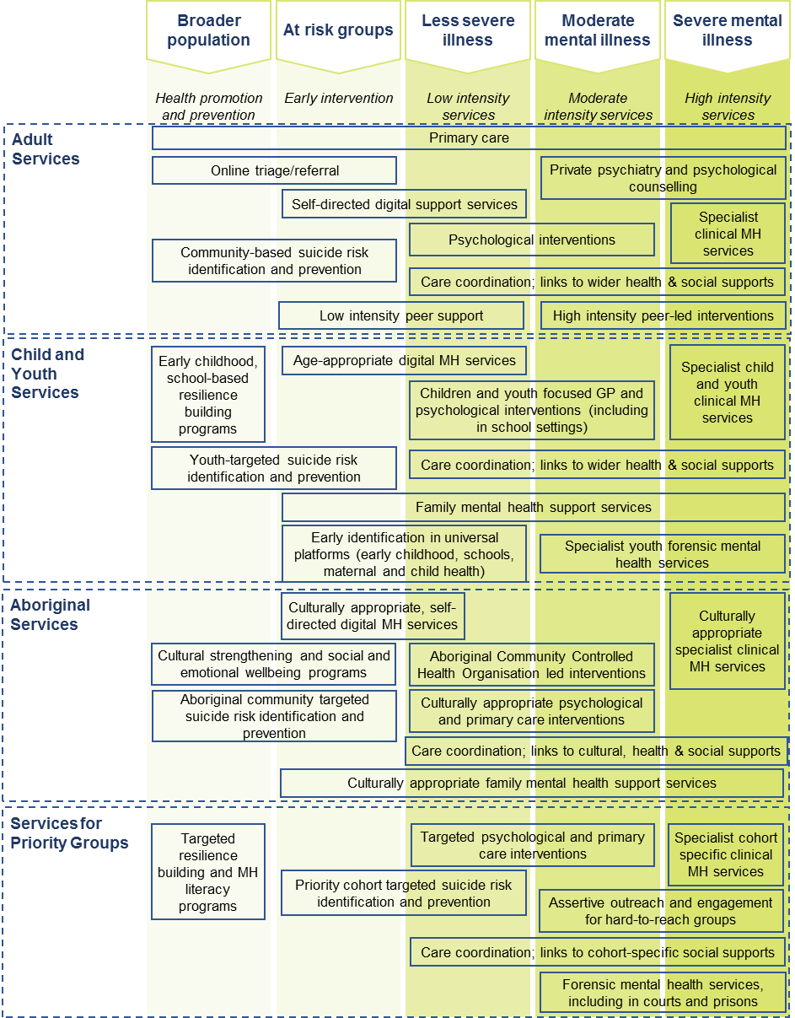

Pathways should be designed to make it easier for people to access and move between services. Lessons from the Royal Commission into Family Violence and other service reform initiatives indicate it is important that:
- intake into services is person-centred, with multiple entry points and a ‘no wrong door approach’.
- services are coordinated, with linkages between a range of different service elements of different intensities and types over a person’s recovery journey.
- consumers can access services in a timely and efficient way, with minimal double-up.
Figure 4 illustrates the key pathways that connect people to appropriate services and supports at the right time and close to where they live. Importantly, leaving the mental health services system should not mean a ‘hard exit’ from support, but rather a step down to other services in the community.
Figure 4: Consumer pathways in a stepped care model
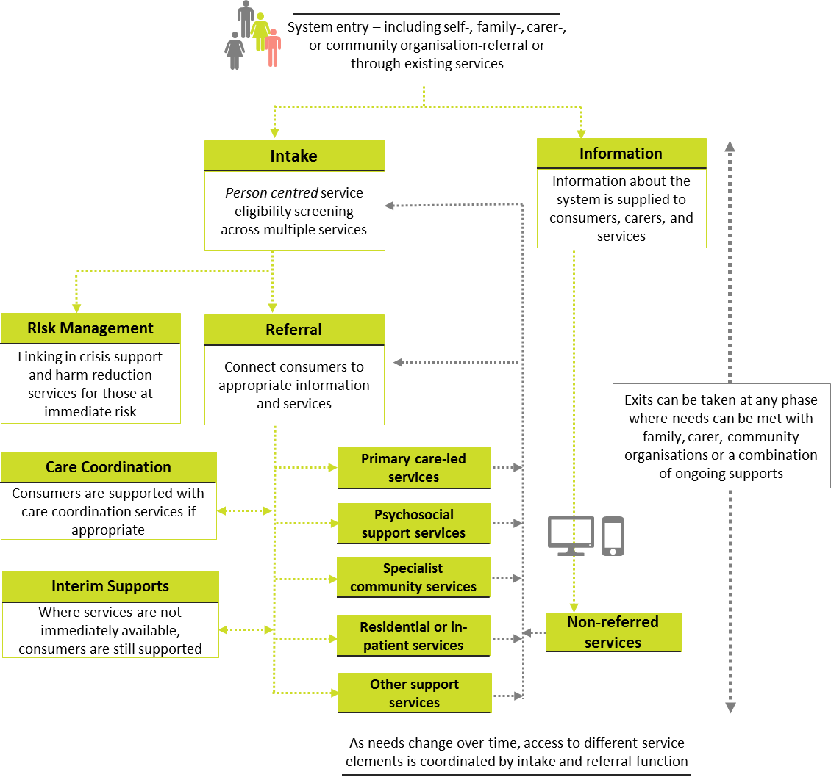

In summary:
- In designing our future mental health system, it would be useful to consider principles that support the delivery of person-centred, actively-managed and timely care.
- Adopting a stepped model of care would ensure that a person presenting to the mental health system is provided with an intervention that suits their current needs.
- Clear pathways are important to support people to access services, move between services and to ensure continuity of care as their needs and circumstances change.

Challenges facing Victoria’s mental health system
Significant population growth in Victoria alongside greater awareness of mental illness, and changing patterns of drug use have meant that demand for mental health services is growing.
Despite efforts to improve the delivery of care, the collective impact of these factors has placed unprecedented pressure on the mental health system over time.
Right now, Victoria’s mental health system does not adhere to the design principles explored in chapter two of this submission.
When measured against the stepped care model, five key gaps are evident in Victoria’s mental health system, namely:
  - an early engagement gap
- treatment gaps for people with moderate or enduring mental illness – the ‘missing middle’
- treatment gaps for people with severe mental illness
- treatment gaps for children and young people
- gaps in the foundations of the system (i.e. governance, funding models, data and information systems, workforce and infrastructure).
These gaps are represented visually in Figure 5 below.

Figure 5: Conceptual overview of gaps in the mental health service system

The impact of these treatment and system management gaps, and their relationship to the proposed design principles, are examined further below.

Early engagement gap
For care to be person-centred, it must be tailored to meet the needs of that person and their family and carers. Person-centred care should be delivered when the need is identified and in settings where it can be delivered without excessive disruption to a person’s daily life.
Improving the mental health and wellbeing of Victorians requires promotion, prevention and early intervention from before birth, through all stages of life. Action is needed across a range of health and non-health settings including online, home, education settings, workplaces, sport and recreational clubs, health services, local communities and in public policy.
A range of different strategies and services models are needed to improve equity of access to primary mental health services. For example, people living in regional and rural areas face geographic barriers to early engagement with mental health services.
Strategies need to be targeted to the general population as well as to at-risk clinical populations. These approaches also need to consider the uneven distribution of risk and protective factors along dimensions such as gender, sexuality, geography, socioeconomic status and cultural identity.
It requires recognition of the impact life events can have in causing or triggering psychological distress or mental illness. Sadly, our services miss too many opportunities for prevention and early intervention, often with the most tragic of consequences.
For instance, while Victoria has frameworks for supporting health and wellbeing, including explicit teaching of social and emotional wellbeing skills for children and young people, these are inconsistently applied in early childhood and education settings across the state.
Our education settings – our schools, TAFEs and universities – provide important opportunities for early identification, support and referral.
Data also shows that there is strong take-up of support in educational settings when it’s made available, with about 40 per cent of all presentations to the Doctors in Secondary Schools program being for mental health issues in 2017.
The lack of person-centred care is leading to an ‘early engagement’ gap, which means there are:
- people who are mentally ‘well’ but who are not supported to remain well through connections to protective or preventative factors, particularly as they age
- people with wider social needs (for example, a lack of stable housing, those experiencing family violence) who may be less able to manage lower acuity mental health issues without early identification and support
- people accessing universal services (such as maternal and child health services and schools) who have risk factors, including risk of suicide, that are not identified and responded to before their mental health deteriorates
- support for people with AOD and mental health treatment needs is not coordinated or available when it is needed
- those at risk of contact with the criminal justice system who are not effectively engaged with the mental health system to manage the continuity of their treatment and behaviour.
Services that provide early engagement with people experiencing, or at risk of developing, mental illness are missing opportunities to respond before symptoms escalate. This includes missed opportunities for people accessing universal services and wider social services.
Many people who experience psychological distress or develop a mental illness may have their first contact with a government service unrelated to mental health, including housing and homelessness services, the criminal justice system, AOD services, education, maternal and child health, specialist family violence services, sexual assault services and physical health services.
For example, around one in 10 new mums experience mental illness during the perinatal period. For less than one per cent of women, this experience is one of serious and acute mental illness, including postpartum psychosis.
These services can play a key role in identifying and, if possible, referring people to the relevant mental health support.
However, apart from a couple of examples of innovative practice, the current mental health system lacks connections with many of these service systems.
Barriers such as service access criteria, gap fees and a lack of services in rural or regional locations also exist for people who may be seeking early help for their mental illness.
Barriers may also be present for minority groups, such as Aboriginal and Torres Strait Islander people, people from culturally and linguistically diverse backgrounds, or people from LGBTIQ+ communities due to a lack of safety or expertise to adequately address the needs of these communities. For some, fear of stigma and discrimination, alongside cultural and language barriers, still play a major role in hindering early engagement with services.
Cultural determinants are also crucial to mental health and wellbeing. Without peoples’ links to culture and community, and without positive connections with family and friends, people’s self-esteem, resilience and sense of individual and collective identity may suffer, to the detriment of their mental health and wellbeing.
If left untreated or unsupported, an individual’s condition can escalate or become enduring and the impact of illness on their lives can create even greater complexity in terms of relationships, employment, housing, and physical health.

Treatment gaps for people with moderate or enduring mental illness – the ‘missing middle’
Active management is critical for people who are experiencing enduring mental health conditions, as both their need for treatment and the impact on their life changes over time.
Active management is too often a missing ingredient for clients in our current system. Those with relatively low and high needs for care – meaning those whose level of need places them on the periphery of a service’s target group – tend to receive treatment temporarily, but then slip through the cracks when their needs change and their engagement with the treating practitioner ends.
This has led to a ‘missing middle’ in the mental health system – a key treatment gap for people with moderate mental illness. This particularly affects people whose illnesses are too complex or enduring to be treated in primary care, but not considered severe enough to meet the high threshold to access constrained specialist mental health services.
The missing middle also affects people with episodic mental health needs and those lacking ongoing support following an acute mental or physical health episode or traumatic experience, where a lack of available services and continuity of care impedes on their recovery and increases the likelihood of further crisis presentations.
Primary care is typically the first point of contact for people seeking help with their mental health, acting as a ‘gatekeeper’ to other service providers. However, current limitations with primary care mean there are people with low to moderate acuity mental illness receiving inadequate support.
A major reason for this is that the level of support provided under the Commonwealth’s Better Access Initiative is not adequate for many people to recover. This may be due to a number of issues leading to inequitable or restricted access to services under the initiatives, such as the cap of 10 sessions per year, and the lack of bulk billing options for those who are not able to afford out of pocket costs. At the other end of the service system, constrained state-funded specialist services only provide treatment to people who are severely unwell.
While most people with moderate mental illness seek help for mental health concerns through GPs, not all needs can be met through this response. Notably, there are shortages of GPs in rural and regional areas of Victoria, limiting entry options to mental health care and meaning people are often very unwell before receiving support. Fragmentation between the primary and specialist systems creates a complicated pathway for people who need help, with the onus on the individual to navigate themselves towards the service that meets their needs.
Psychosocial supports can also play a critical role in enabling people who experience moderate to severe illness, particularly those with an enduring illness, to recover in the community. Gaps in psychosocial service delivery arising from the transition to the NDIS are also contributing to the missing middle.
People with unmet needs for treatment and care are often forced to seek assistance elsewhere or are left without help until their illness gets worse. This means that unmet or hidden demand for mental health services may manifest as costs in other government services, such as justice and homelessness services.

Treatment gaps for people with severe mental illness
Constrained capacity in our acute mental health services has meant that the threshold for mental health service responses in the community is high. This has contributed to increasing first time presentations at hospital emergency departments and increased contact with the criminal justice system (i.e. police contact, presentation at court, remand and prison admission).
Bed occupancy for adults is at 95 per cent. However, the average length of stay for adults has continued to trend downwards. In 2009, length of stay was on average 14 days. Since then, it has decreased to 9.5 days in 2015-16 and 9.1 days in 2017-18.
Despite rising thresholds at intake, severely unwell consumers now receive around one third of the number of contacts received ten years ago. The average rate of client contacts in Victoria is 252.9 contacts per 1,000 population, while the national average is 365.2 contacts per 1,000 population. Consequently, the rate of improvement at discharge from care has declined over the last decade.
This has led to treatment gaps for people with severe mental illness. People who are acutely unwell and may have multiple health needs are being discharged to community-based services before they have fully recovered.
This can create a cycle that drives people experiencing mental illness to return to emergency departments and acute inpatient care. Without appropriate community-based care dedicated to meeting the needs of each individual, the system risks increased inpatient readmissions, generating more demand on our hospitals and people becoming entrenched in the justice system. Victoria Police are increasingly first responders to incidents involving people with severe mental illness. In 2017/18, Victoria Police attended approximately 43,000 events relating to a psychiatric crisis or suicide attempt or threat, and attended a mental health call out approximately every 12 minutes. Service gaps and options for reform regarding police contacts related to mental health will be detailed in a separate submission from Victoria Police.
Furthermore, people experiencing severe mental illness in regional and rural areas of Victoria often have very few options for community-based support near where they live, which can mean they return to their community without appropriate care.
Forensic mental health services
Forensic mental health services are a small but critical part of the specialist service system. Their role is to assess and treat those people in the criminal justice system. There is a significant gap in responses for prisoners suffering severe mental illness who require compulsory treatment that can only be provided in a hospital setting.
Constrained bed capacity in the Thomas Embling Hospital means that prisoners requiring compulsory treatment are waiting lengthy periods of time in prison to receive treatment, including those found not guilty due to mental impairment under the Crimes (Mental Impairment and Unfitness to be Tried) Act 1997.

Treatment gaps for children and young people
In Australia, mental disorders are the highest ranked contributor to the total burden of disease in late childhood (10-14 years) and adolescence (15-19 years). In Victoria, 12.6 per cent of Victorian parents reported being concerned about their child’s emotional and psychological health upon entry to school.
We know that the delivery of care should be effective and deliver the best possible outcomes for each individual. Despite this, there are current challenges to supporting children, young people, their carers and families to develop and maintain good mental health.
In addition to the prevention and early intervention gap identified above, the ‘missing middle’ is also present for children and young people.
Use of early intervention services for children is on the rise. Victorian use of general practice mental health-related Medical Benefits Scheme for those between 5 and 12 years of age has increased substantially from 4.8 per cent in 2011-12 to 8.1 per cent in 2017-18.
However, available services are not always appropriate to meet the needs of children and young people experiencing moderate to severe mental health issues. It means that for young people with more complex needs, there are few alternatives between their local primary health care providers and crisis point.
There is also a need to strengthen approaches to engage, assess and treat infants and children and families experiencing psychological distress. This is due to continuing growth in demand across the child and family system, including earlier intervention family services and high risk populations such as child protection and youth justice services. In turn, this demand is driving a focus towards crisis response for children and families at significant risk.
In particular, there are high numbers of young people presenting to emergency departments in mental health crisis. A 2018 study found that between 2009 and 2015, there were 52,359 mental health presentations to Victorian public emergency departments by children and young people aged between 0 and 19 years for intentional self-harm and mental health problems. During the 7-year period, presentations increased by an average of 6.5 per cent each year.
We also know that more tailored child and adolescent responses are needed to support young people and their families or carers following a suicide attempt.
Current specialist child and youth mental health services are also delivered with different models of care and under different governance arrangements across Victoria. This makes it difficult for children, young people and their families to navigate the system and leads to inconsistent access to appropriate, locally-based treatment and support tailored to the needs of these groups.
The misalignment of geographic service boundaries between child and youth mental health services and other services has contributed to this issue, hindering effective statewide planning for mental health services for this cohort.
A ‘postcode lottery’ has also emerged within this part of the specialist system due to inconsistent service offerings across the state and a lack of choice for consumers.
It has also created a more complex system to navigate, a lack of connection to other services and transition gaps for young people who progress into the adult system.
There is also opportunity to provide early intervention psychosocial rehabilitation supports tailored to the developmental needs of young people with severe mental illness, helping to prevent or reduce disability and social disadvantage associated with life-long mental illness.

Gaps in the foundations of the system
Some of the treatment gaps described above are compounded by the failure of key aspects of our system, including fragmented system governance, unrefined approaches to demand forecasting, data limitations that inhibit planning and outcomes monitoring, and workforce constraints.

Governance
Given roles and responsibilities within the mental health system are shared across levels of governments and other partners, a stepped care model will require strong system governance and connection between providers in each local community.
Mental health service governance and delivery must also be embedded within the broader health system. At present, treatment gaps are complicated by a complex and fragmented service system.
Geographic catchments, a key structural element of the specialist system design, are not working as well as they should be. As noted recently by the Victorian Auditor-General, misaligned catchment boundaries are preventing people from accessing services. Rigid catchment boundaries also mean that demographic changes, such as growth corridors, can create inequity in service access.
As identified in chapter one, Victoria’s mental health system includes services funded by the Commonwealth and delivered largely in private settings, as well as an array of Victorian Government services. Fragmentation between these primary and specialist systems also inhibits local connection and creates a complicated pathway for people who need help, with the onus on the individual to navigate themselves towards the service that meets their needs.
Fragmentation is particularly challenging in children and youth mental health, where services are delivered with different models of care and under different governance arrangements across Victoria.
Further to the above, responsibility and accountability for quality and safety oversight of the specialist mental health system is distributed across multiple bodies, including the Chief Psychiatrist, the Chief Mental Health Nurse and Safer Care Victoria. The Mental Health Complaints Commissioner, Mental Health Tribunal and the Office of the Public Advocate (Victoria) also have a range of statutory functions linked to the operation of the Mental Health Act
This complexity can create a level of confusion around accountability and may inhibit continuous improvement efforts.

Funding mechanisms
Unlike with other health services, mental health funding has been allocated on a historical basis and is not adjusted for wide disparities in the needs and complexity of clients.
Funding for specialist mental health services in Victoria is input and program-based. Inpatient care is funded at a daily rate according to bed capacity at each health service. Community contacts are funded at an hourly rate and specific grants are provided for particular service functions or individual programs.
These mechanisms for funding are unresponsive to changes in the population and are inflexible to the needs of different groups or individual clients.
Some packaged funding approaches exist for community-based treatment and care, but this is limited to certain service types and not applied to large numbers of clients.

Data and information systems
Estimating true demand for mental health services is challenging, due to existing gaps and because of shortcomings of existing triage and information systems. Demand for mental health services is often ‘unmet’ or ‘hidden’ due to the nature of mental illness, meaning that the most unwell may be less likely to seek out treatment.
Projecting demand has been partly hindered by a lack of information or ineffective use of the information that is available. This then inhibits our ability to understand and meet demand for mental health services, with information critical to informing overall funding, capital infrastructure and service distribution.
Data limitations also limit the ability to measure and report on outcomes. The Victorian Government monitors indicators within Victoria’s mental health outcomes framework and reports on them annually in Victoria’s Mental Health Services Annual Report. However, there have been reporting challenges because data is not always available or comparable over consecutive years. Time series data showing trends in health and wellbeing outcomes was only published for the first time in Victoria’s 2017-2018 Mental Health Services Annual Report.
Further, changes in sampling methods, methodologies and gaps in data collection reduces the Victorian Government’s ability to link data and create a complete picture over time. Obtaining current, valid and reliable health data about Aboriginal Victorians also remains challenging.

Workforce
A high-performing, well-led, sustainable workforce is critical for ongoing delivery of, and improvement in, mental health treatment and care in Victoria.
Workforce shortages in the mental health sector adversely impact services for people experiencing mental illness, and their carers and families.
Workforce shortages limit the capacity to flexibly respond to demand and deal with severe and complex presentations. In some cases, shortages in key nursing and medical staff have delayed the opening of new mental health beds.
This has led to higher caseloads for staff and increased thresholds for access to care. The pressure on staffing resources can also impact on quality and safety, creating conditions that foster greater reliance on seclusion and restraint and less care coordination.
Health services report difficulties in recruiting and retaining skilled mental health clinicians across all key disciplines – nurses, psychiatrists, social workers, occupational therapists and psychologists. Factors underlying these difficulties include the perception of mental health as a less prestigious career opportunity for new graduates, worker safety and wellbeing concerns, inadequate supervision and mentoring structures, and lack of development opportunities.
Workforce shortages are more pronounced in certain settings (inpatient units), disciplines (mental health nursing vacancies are sitting at approximately 10 per cent) and subspecialties (including addiction psychiatry, youth, child and adolescent mental health and forensic mental health).
The most significant issue is the distribution of workforces across regional areas and metropolitan areas, as observed in the health sector more generally. Over 93 per cent of psychiatrists are in the major cities of Melbourne and Geelong, and as noted recently by the Victorian Auditor-General, the current workforce strategy does not address these issues or articulate specific targets.
Further, many people who experience psychological distress or develop a mental illness have their first contact with a government service unrelated to mental health. These services include Centrelink, housing and homelessness services, family violence services, education, maternal and child health, corrections, police and other health services, including GPs.
While these services can play a key role in identifying and providing support to people with mental illness, their capacity to identify and respond to people at risk of or experiencing mental illness is limited.
Inadequate state-wide workforce data systems mean that timely information regarding mental health workforce is also lacking, impeding effective workforce planning and modelling.
Supporting the mental health of Victorian Government workforces, including first responders
As an employer, the Victorian Government also has a duty to protect the health, safety and wellbeing of its employees. With the increasing prevalence of mental injury in the workplace and the risk of occupational violence, this is a significant consideration – particularly for frontline workforces and first responders.
The Victorian Government has already commenced a significant body of work to improve the health and wellbeing of public sector employees, through the Mental Health and Wellbeing Charter, targeting occupational violence and provisional payments for mental health injuries.
However, there remain challenges in building capability across such workforces in responding to people experiencing mental illness or crisis.
The Victorian Government has engaged with the Productivity Commission’s Inquiry into mental health on this issue, as the inquiry has a focus on mental health in the workplace.

Infrastructure
Long-term state-wide planning for mental health facilities has been inhibited by the governance arrangements and data limitations discussed above. This means that infrastructure for the mental health system has also failed to respond to demand, emerging best practice and changing demographics.
Few new facilities have been developed over the past 10 years when compared to medical facilities and, several site-specific assessments have identified buildings accommodating mental health services to be in poor or very poor condition.
The delivery of bed-based services can be constrained by the limited number of bed numbers, particularly in areas experiencing high demand. Furthermore, the delivery of some specialist services such as forensic mental health services, are constrained by the limited capacity of fit-for-purpose facilities. There are also often long-lead times in developing appropriate facilities.
As a result, only a small number of consumers and workers benefit from contemporary mental health environments with design informed by international best practice.

In summary:
- Principles for design of a future mental health system can help to identify and assess opportunities for reform.
- There are gaps in the Victorian mental health system across the continuum of service responses, from prevention and early intervention through to treatment and care for people living with moderate and severe mental illness.
- Gaps in key aspects of the mental health system, including governance and funding models, are compounding system challenges.
- These gaps are significantly impacting on the mental health outcomes of Victorians, as people often do not have access to the treatment they need, when they need it.
- As noted earlier, the Victorian Government has actively sought to address known issues in the service system. However, it is apparent that more needs to be done to address the root-causes of these gaps.

Priority reform opportunities
Drawing on principles for the design of a future mental health system, the previous chapter identified several key gaps evident in Victoria’s current mental health system.
While the Victorian Government has various initiatives underway to improve our states system, the Royal Commission provides a platform to address these gaps, moving towards the key service elements and effective pathways required for a stepped care model.
Six reform priorities are identified for consideration by the Royal Commission. These priorities have been identified as a means of addressing current gaps and improving access to services that are delivered in a way that is appropriate to each individual’s personal circumstances.
To progress towards a more comprehensive and coordinated stepped care model, the Victorian Government is seeking the Royal Commission’s guidance on whether particular priority should be given to:
- strengthening primary mental health care
- expanding community-based care
- contemporary models of care for people who are severely unwell
- better using other service systems to support mental health
- enhancing child and youth mental health
- strengthening key enablers of the specialist mental health service system.
It is important to note that the Victorian Government does not hold all the levers to act upon all these opportunities, but supports a collaborative approach with key partners across the sector. Each of these potential areas for focus are explored in more detail below.

Strengthening primary mental health care
Improving access to primary mental health care in Victoria would support greater early intervention and reduce future demand in the specialist mental health system.
This would mean that people receive earlier, more integrated care that recognises their broader health and social needs. It would also mean more people are able to manage low acuity illnesses and fewer people miss out on care because their illness is seen as too challenging for primary care.
To adopt a stepped care model across the mental health system, stronger connections between primary care and specialist services would be necessary. This would make it easier for people to move between services without needing to re-tell their story. It would also create more pathways for GPs to fast-track access to specialist services for people with high needs, particularly those who pose a risk to themselves.
In envisioning the future mental health system, there are opportunities to draw on international evidence and consider how Victoria could:
- build the capacity of primary care practitioners to identify, assess and support people with low to moderate levels of acuity
- develop innovative new funding and service models in primary care, in collaboration with key partners (including PHNs) to ensure services are available and affordable
- leverage existing primary care platforms to expand access to primary mental health services
- develop secondary consultation models or other approaches to better support mental health treatment in primary care
- develop models for treatment of cooccurring mental illness and problematic alcohol and drug use in primary care
- improve identification of suicide risk in primary care settings, and create supported pathways for people at risk of suicide to appropriate services, including following a suicide attempt
- create stronger pathways in and out of primary care to ensure people are provided with better support when transitioning to, or from, specialist services.
There are international examples that can support exploration of how best to strengthen primary care. Reform in New Zealand and the Netherlands provides indications of how strengthening primary care can reduce the strain on acute services and improve health more broadly.

Expanding community-based care
The current Victorian mental health system is heavily focused on inpatient and crisis aspects of care for people with severe mental illness.
Expanding the capacity of specialised community-based services would help reduce the reliance on acute inpatient beds and ensure that people with higher acuity conditions and complex behaviours have access to appropriate care in a more therapeutic setting. For people with enduring or episodic needs, this would ensure they are provided with stronger support, particularly following a crisis.
Flexible service delivery models in the community would better recognise that people’s needs change over time. Community-based care also has the potential to provide interventions that are the least intensive and intrusive for consumers.
There is no clear strategy within Victoria on the best mechanisms for expanding community-based care. As such, the Victorian Government would welcome advice on practical actions to:
- better prioritise sub-acute and community care, including residential care, for people with higher acuity needs and longer-term conditions to provide step-down care following acute episodes of illness
- innovative models of community-based care delivery for rural and regional Victorians
- establish community-based service models that would better support people with dual diagnosis and dual disability
- effectively deliver assertive outreach models to support specialist community-based services to engage with people who experience barriers to access, including those who live in regional and rural locations
- drive equivalence of care for people in the justice system, such as potential sub-acute service models
- strengthen the use of non-clinical models of care, including peer-based approaches, in particular for those who may not be able to access psychosocial supports under the NDIS.
International models may provide some guidance to the Royal Commission in exploring this reform opportunity. For instance, Trieste (Italy) and the Netherlands are examples of systems that have successfully transitioned from hospital to community-based mental health care.

Contemporary models of care for people who are severely unwell
Advice on how acute responses could best be delivered – including for people in crisis and people in contact with the justice system – is a critical question for a reimagined mental health system with a strong community focus. This includes people in the community who may not otherwise come to the attention of the mental health system, as well as people presenting to emergency departments as their ‘first port of call’.
The Victorian Government would welcome the Royal Commission’s guidance on how best to support people who are severely unwell, including:
- whether existing service models could be bolstered and ideas on new service models to respond to people in crisis, including those at risk of self-harm and suicide
- how best to structure and scale outreach models to continue supporting people following a crisis, particularly in regional and rural locations
- the optimal design of triage functions to ensure that health services deliver accessible, responsive and clinically appropriate triage assessment and referral
- easing the growth of emergency department presentations and police contacts related to mental health and creating more appropriate entry points to the system
- the appropriate mix of investment required to support a balanced system of acute and community-based services, including within the justice system
- service models for people with multiple and complex needs, particularly those with cooccurring mental illness and problematic drug and alcohol use
- the provision of psychosocial rehabilitation and disability support to help people to build their individual ability for self-care, self-management and self-determination.
These changes should be considered for early action, given the catastrophic impact for people who are experiencing mental health crises, including people at risk of suicide.

Better using other service systems to promote and support mental health
Successive reviews of social service systems have emphasised the importance of more effective interfaces between mental health, health and broader service systems to better support people experiencing or at risk of mental illness.
Improving mainstream interfaces would mean people at risk of mental illness are identified earlier and are better supported to maintain good mental health.
There are also opportunities to better use other service systems to prevent mental illness and sustain recovery. This spans from activities targeted at the early years, such as school-based frameworks for supporting children and young people to develop their social and emotional skills, to initiatives seeking to address social isolation and support at-risk cohorts and communities.
Advice from the Royal Commission on leading opportunities to best use other services systems to support mental health would be highly valued, including how Victoria could:
- better promote resilience and reduce risk factors associated with mental illness through all government service systems
- take advantage of wider opportunities to support specific cohorts and communities
- expand place-based prevention approaches that target locations with higher rates of suicide, family violence and socioeconomic disadvantage
- embed mental health supports for clients that access multiple government services in other community and social care platforms and deliver new assertive outreach models
- further build the capacity of health professionals providing support in universal settings (e.g. schools and maternal and child health services) to help them with risk identification, assessment and initial support for people and their families
- improve the interface between the mental health system and other service systems to provide a more seamless and holistic response for people with mental health issues, including through the development of pathways to specialist services and the NDIS
- improve access to affordable housing and employment services.

Enhancing child and youth mental health
Building on the foundations of a child and youth mental health system that exist in Victoria, we would welcome guidance from the Royal Commission on how best to tackle the prevention and treatment gaps identified in chapter three.
This will likely include further opportunities using other platforms, including early childhood settings, schools, TAFEs and universities to better support children. It is also likely to encompass supporting a stronger approach in sectors dealing with children and families, such as parenting services, community services and refugee health services. Effectively responding to childhood trauma is critical to mitigating risks of poor mental health among vulnerable children and young people in these settings.
We would welcome guidance from the Royal Commission on the shape of future reform to child and youth mental health, including how Victoria could:
- improve and streamline entry to youth mental health services, including through potential collaboration with the headspace platform
- ensure the delivery of best practice clinical and psychosocial models of care for children and young people, including through new service models for young people with more complex mental health needs
- more effectively identify and help parents and families where there are risks to children and young people’s mental health, including opportunities to intervene early through perinatal and parental mental health services
- provide a more comprehensive and consistent suite of specialist mental health supports, particularly for children and young people living in regional and rural communities
- better respond to risk of suicide of children and young people, and provide supported recovery pathways for self-harming behaviour or suicide attempts
- better identify and support children and young people who are at a high risk of contact with the criminal justice system
- enhance mental health assessment, treatment and support for youth justice clients in custodial and community settings with a focus on continuity of care
- ensure appropriate harm reduction and treatment options are available to support young people with harmful AOD use
- better coordinate mental health services with housing, AOD, child protection, family violence services and other services accessed by vulnerable young people.

Strengthening foundations of the system
There are several enablers that support effective delivery of high-quality and safe specialist services in the mental health system. Given the lead time required to progress work in many of these areas, there is opportunity for the Royal Commission’s interim report to provide recommendations to guide reform.
Progressing early work on key enablers will make it possible to commence delivery of systemic change more promptly following the final report of the Royal Commission.

Governance
Governance mechanisms can develop strong pathways and connections within local areas to help identify a person’s care needs quickly and identify the provider with the right skills and expertise to support that person. They also help to support a person across their recovery journey, with better continuity of care particularly for people with enduring mental illness.
The alignment of clinical mental health service catchments for children, youth and adults with Victorian PHN regions and other health and human service areas (based on local government areas boundaries) would support a stepped model of integrated mental health care for Victorian children and young people.
This would facilitate a more coordinated and consistent approach to service planning, commissioning and delivery including improved integration between primary, secondary and tertiary services and with other health and human services.
Based on these new area mental health service boundaries, the Victorian Government could better identify and respond to current and predicted population growth, demographic needs and socio-economic indicators.

Data and information systems
Current systems used to capture client and system performance data are no longer fit for purpose. A redesign of the client management system would facilitate the delivery of high-quality services.
In particular, development of a centralised live information system would support more active statewide monitoring, stronger forecasting and more timely quality improvement. Further, a redeveloped system would reduce clinician documentation burden which currently requires data entry across multiple systems.
In addition, centralised triage data capture at the gateway to the specialist service system would support stronger oversight of specialist mental health service access. This would make it possible to determine whether people are being appropriately triaged, or whether they are not being admitted to services because of pressures on the available resources.
The Royal Commission also has an opportunity to recommend that the Victorian Government refine data collection definitions, methodologies and mechanisms to collect standardized and comparable data on outcomes.
We would welcome the Royal Commission’s advice on how we could progress with developments to ensure we have the system capabilities to support strong management and oversight, focused on achieving outcomes for individuals and the community.

Workforce
In considering a future sustainable mental health system, an integrated workforce information system would make it possible to identify workforce shortages across all disciplines, undertake forecasting, and understand patterns of people exiting the workforce.
It would also help to ensure efforts to grow the workforce are appropriately targeted to meet current and future needs. For example, we know there is a need to build a workforce with dual capability across AOD and mental health. This could be complemented by stronger partnerships with agencies involved in sector development to support a workforce pipeline targeted to areas of need.
There are also workforce shortages across key disciplines that the Royal Commission could explore how best to address. These shortages are felt more strongly in regional and rural areas of Victoria.
There is an opportunity to provide stronger mental health promotion, illness prevention and early intervention through building the capabilities of workforces in other settings. This includes workforce capability uplift across the health, justice, education and social services settings and for workforces with particular workplace mental health challenges, and those workforces that more regularly deal with others’ mental health challenges such as first responders.
In expanding and building on the existing capability of the workforce, we would welcome attention from the Royal Commission on how best to grow the lived-experience and Aboriginal mental health workforces. Attention could also be directed towards developing career pathways and strengthening access to practice leadership, workforce support and clinical guidance to help ensure workers remain in the mental health sector. This could include opportunities for the Victorian Government to build resilience and protect the safety, mental health and wellbeing of government workforces more broadly.

Infrastructure
People living with mental illness need safe and supportive physical environments to receive care and recover. The physical environment is also critical to the effective delivery of an evidence-informed service model.
Across our affordable housing, schools, hospitals, correctional system and wider community, there are opportunities to draw on international leading practice to promote more contemporary mental health environments. In particularly, advice is sought on how to maximise safety in mental health facilities, for both consumers and the workforce.
There is also a need to ensure there is enough infrastructure capacity in place across our state to provide appropriate mental health care to people who need it. Different facilities should be available to support people with different mental health needs, consistent with a stepped care model.
Guidance is sought from the Royal Commission on early infrastructure priorities across acute, community and forensic settings.

Research and innovation
To ensure a sustainable system that is continuously improving, the mental health service system should be guided by the best possible evidence and research and should flexibly adapt and respond to developments in technology and practice.
While the system currently has examples of evidence-informed practice and service models, systemic mechanisms to support continuous development and improvement of mental health services are required.
We would welcome the Royal Commission’s recommendations relating to the establishment of a ‘learning system’, that includes system-wide approaches to monitoring, evaluating and renewing approaches to mental health treatment and care in Victoria.

In summary:
- The Victorian Government would welcome the Royal Commission’s advice on a number of priority areas for reforming the mental health system in Victoria.
- Addressing these priority areas for reform will help to tackle gaps in the mental health system that are preventing all Victorians from receiving the care they deserve.
- Early effort on improving the foundations of the system, including governance, data and information systems, workforce and infrastructure can help support future reform objectives and promote the sustainability of the mental health system.

Appendix

Description of figures

Figure 1: Expenditure on mental health services in Victoria
Figure 1 illustrates that expenditure on mental health services in Victoria is split between Victorian Government and Commonwealth Government Mental Health funding.
In 2018-19, the Victorian Government funded $1.5 billion on clinical care, $98.9 million on mental health community support services, and $259.9 million on drug and alcohol services. The Commonwealth Government provided $360 million to primary mental health services through the Medicare Benefits Scheme in 2017-18, $752 million to non-admitted mental health services in 2018-19 and a contribution to hospital-based mental health services. National Disability Insurance Scheme funding is spread across both Victorian and Commonwealth Governments.
Other Victorian Government services also contribute to mental health outcomes.

Figure 2: Victorian Government’s mental health output cost, 2018-19
Figure 2 illustrates that the Victorian Government Output Cost for mental and alcohol and other drugs in 2018-19 was a total of $1,864.7 million. Of the $1,506 million cost for clinical care, $433 million is for admitted care, $126 million is for subacute and residential care, and $687 million is for non-admitted care. Of the $98.9 million cost for community support services, $75 million is for community support services, $6 million is for mutual support and self-help, $5 million is for planned respite and $4 million is for supported accommodation. Of the $259.9 million cost for alcohol and other drug services, $235 million is for drug treatment and rehabilitation and $21 million is for drug prevention and control. The cost for National Disability Insurance Scheme psychosocial and transition support packages is $28 million. The cost for Aboriginal services (Aboriginal Controlled Community Organisations) is $7 million.

Figure 3: Indicative stepped care model
Figure 3 provides an indicative stepped care model. It categorises the population into five groups: the broader population (health promotion and prevention), at risk groups (early intervention), less severe illness (low intensity services), moderate mental illness (moderate intensity services) and severe mental illness (high intensity services).
Figure 3 presents various service responses for each of the five groups according to four cohorts: adult services, child and youth services, Aboriginal services, and services for priority groups.

Figure 4: Consumer pathways in a stepped care model
Figure 4 illustrates consumer pathways in a stepped care model. Beginning at system entry, a person may enter through an intake service or be provided with information (which may lead them to non-referred services). Through intake, a person may have a risk management response or they may be referred to an appropriate service. Referral may be to care coordination or interim supports, or other services: primary care-led services, psychosocial support services, specialist community services, residential or inpatient services, or other support services. Exit may occur at any time if needs are met by other supports.

Figure 5: Conceptual overview of gaps in the mental health service system
Figure 5 shows a conceptual diagram of gaps in them mental health system. It shows that there are three service availability gaps: an early engagement gap impacting at risk groups, a missing middle gap impacting the 4-7% of the population with moderate severity mental illness, and a severe mental illness gap impacting some of the 2-3% of the population with severe mental illness. There is a fourth gap for children and young people, and a fifth gap in the foundations of the mental health system, namely governance, funding models, data and information systems, workforce and infrastructure.

Australian Institute of Health and Welfare, Mental health services in Australia, 2018 <https://www.aihw.gov.au/reports/mental-health-services/mental-health-services-in-australia/report-contents/expenditure-on-mental-health-related-services>
Victorian Department of Treasury and Finance, Budget Paper 3: Service Delivery, 2018-19 <https://www.dtf.vic.gov.au/sites/default/files/2018-05/2018-19%20State%20Budget%20-%20Service%20Delivery_0.pdf>
Victorian Department of Treasury and Finance, Budget Paper 3: Service Delivery, 2019-20 <https://www.dtf.vic.gov.au/2019-20-state-budget/2019-20-service-delivery>
*Victorian Department of Treasury and Finance, Budget Paper 3: Service Delivery, 2018-19 <https://www.dtf.vic.gov.au/sites/default/files/2018-05/2018-19%20State%20Budget%20-%20Service%20Delivery_0.pdf> **Australian Institute of Health and Welfare, Mental health services in Australia, 2018 <https://www.aihw.gov.au/reports/mental-health-services/mental-health-services-in-australia/report-contents/expenditure-on-mental-health-related-services> ***Independent Hospital Pricing Authority, National Efficient Cost Determination 2018-19, 2018 <https://www.ihpa.gov.au/sites/default/files/publications/national_efficient_cost_determination_2018-19.pdf>
Australian Institute of Health and Welfare, Mental health services in Australia, 2018 <https://www.aihw.gov.au/reports/mental-health-services/mental-health-services-in-australia/report-contents/medicare-subsidised-mental-health-specific-services>
Australian Institute of Health and Welfare, Mental health services in Australia, 2018 <https://www.aihw.gov.au/reports/mental-health-services/mental-health-services-in-australia/report-contents/expenditure-on-mental-health-related-services>
Australian Institute of Health and Welfare, Mental health services in Australia, 2018 <https://www.aihw.gov.au/reports/mental-health-services/mental-health-services-in-australia/report-contents/medicare-subsidised-mental-health-specific-services>
Victorian Department of Health and Human Services, Victoria’s Mental Health Services Annual Report, 2017-18 <https://www2.health.vic.gov.au/mental-health/priorities-and-transformation/mental-health-annual-report>
Australian Government Department of Health, National mental health strategy, 1992 <https://www.health.gov.au/internet/main/publishing.nsf/Content/mental-strat>
Victorian Department of Health and Human Services, Victoria’s 10 Year Mental Health Plan, 2015 <https://www2.health.vic.gov.au/mental-health/priorities-and-transformation/mental-health-plan>
The Australian Government Department of Health, Fifth National Mental Health and Suicide Plan, 2017 <https://www.health.gov.au/internet/main/publishing.nsf/Content/mental-fifth-national-mental-health-plan>
Mental Health Act 2014
Adapted from South Eastern Melbourne Primary Health Network, Mental Health Stepped Care Model, 2017 <https://www.semphn.org.au/images/downloads/Links_Page/SEMPHN_Stepped_Care_Model_6_6_17.pdf>
Adapted from South Eastern Melbourne Primary Health Network, Mental Health Stepped Care Model, 2017 <https://www.semphn.org.au/images/downloads/Links_Page/SEMPHN_Stepped_Care_Model_6_6_17.pdf>
Victorian Department of Education and Training, Doctors In Secondary Schools Program Activity Data, 2017 <unpublished>
Victorian Department of Health and Human Services, Victoria’s Mental Health Services Annual Report, 2017-18 <https://www2.health.vic.gov.au/mental-health/priorities-and-transformation/mental-health-annual-report>
Mental Health Services in Australia, 23 April 2019 Table CMHC.1: Community mental health care service contacts, patients and treatment days, states and territories, 2016–17
Institute of Health Metrics and Evaluation, Global Burden of Disease Compare. Seattle, USA, 2017, <https://vizhub.healthdata.org/gbd-compare/>
Victorian Department of Education and Training, School Entrant Health Questionnaire 2017, November 2018 <https://www.education.vic.gov.au/Documents/about/research/SEHQ2014/SEHQ%20snapshot.pdf>
Australian Government Productivity Commission, Report on Government Services, 2019 <https://www.pc.gov.au/research/ongoing/report-on-government-services/2019/health/mental-health-management>
Hiscock, H., Neely, R. J., Lei, S. & Freed, G, Pediatric mental and physical health presentations to emergency departments: Victoria, 2009-15, 2018, The Medical Journal of Australia, 208(8)
Royal Australian and New Zealand College of Psychiatrists, Psychiatry Attraction, Recruitment and Retention Needs Analysis Project, 2017 <https://www.ranzcp.org/files/branches/victoria/ranzcp-vic-psychiatry-workforce-report.aspx>

